Lecture 4 (Ch 24)

Gauss’s Law



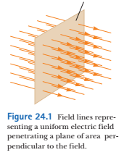

Electric Flux: Φ = Electric field × Area

Φ unit is Nm2/C

Visually, electric flux is proportional to the number of electric field lines penetrating the area A

If the surface is parallel to the electric field E, then the flux through the surface area is zero

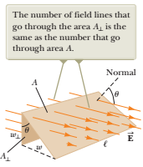 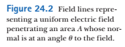

If the surface normal has an angle θ with the direction of the Electric field, then electric flux through this area A is:

$Φ=E∙A∙cosθ$

side view for Figure 24.2

Electric flux $Φ=E∙A∙cosθ= \vec{E}∙\vec{A}$ ( a scalar product)

the direction of the vector $\vec{A}$ is the direction of the normal

For the general case of the electric field and arbitrary surface:

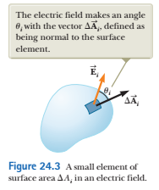

$∆\vec{A}$ magnitude is the area and the direction is the normal to the surface element

The electric flux through this element is:



The total flux through the surface is:



in the limit (element area -> 0):



Closed surfaces: e.g. sphere

in the closed surface normal points outward

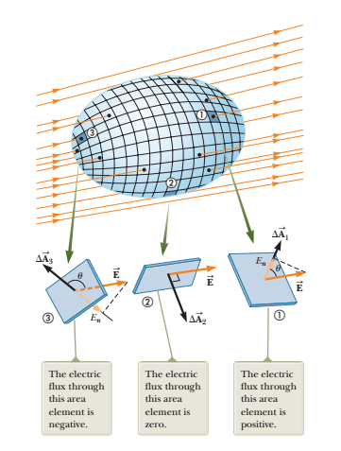 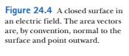

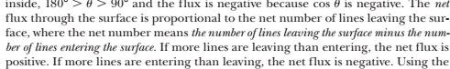

Net flux through the surface is:



En is the normal component of the electric field

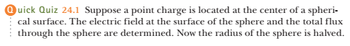

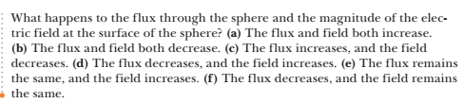

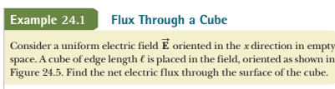

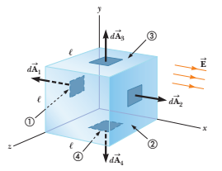 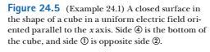

compute the flux through the faces 1, 2, 3 and 4:

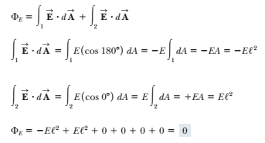



Gauss’s Law describes relationship between the charge enclosed in the closed surface and the net electric flux through the surface

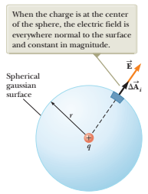 

we will use the formula 24.4 (below):



From Figure 24.6:



Hence, the surface integral 24.4 is:



We moved E outside of the integral since E is constant on the surface

The surface integral is 4πr2

E = kq/r2

Hence, Flux is:



Since k = 1/4πε0 ,



What if the surface is not spherical?

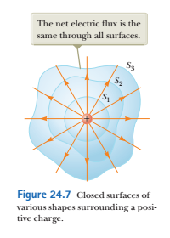

The flux through the surfaces S1 S2 S3 is the same (the number of electric field lines is the same) . Hence,



If the charge is outside the closed surface,

then the net electric flux through the surface is zero:

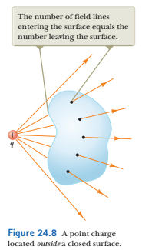

General case: charges q1 , q2 q3 …

the flux through any closed surface is:



E here is total electric field on the surface (from all charges)

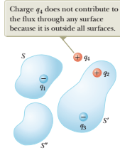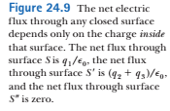

Gauss’s Law:



E is the total electric field on the surface from all charges, qin is the charge inside the surface

Gauss’s Law is convenient for calculation of electric fields for symmetric systems: spheres, cylinders etc.

